Reference Australian Newspaper
https://www.theaustralian.com.au/nation/world/sri-lanka-to-deport-foreign-islamic-teachers/news-story/f06083dedcf31a6c0ade0ba9c5e8b6a2?fbclid=IwAR0A4pufQmjTBuN-CSVHpNVwfTBVoNK2LZFP_Q8ioOoMkntbKiEfVzqOvLI
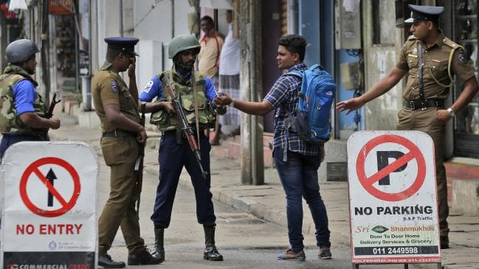
Sri Lankan Prime Minister Ranil Wickremesinghe has ordered the deportation of potentially hundreds of foreign Islamic teachers as authorities continued their search last night for more than 100 people suspected of involvement in the Easter Sunday terror attacks.
The Island newspaper reported yesterday that Mr Wickremesinghe had instructed officials to find and deport all such teachers operating on tourist visas, and that he also demanded a report from the Ministry of Muslim Affairs detailing where they were staying and how they obtained visas.
The order came as the government began enforcing its nationwide ban on full-face coverings, brought into law at the weekend in response to the co-ordinated suicide bombings of churches and hotels that killed 253 people.
The new law, which is supported by most of the country’s moderate Muslim organisations, prohibits all garments or material that conceal the face and ears from being worn in any public place, including roads, bridges, buildings, public and private vehicles (except mandated helmets).
The country remains on high alert as thousands of troops sweep homes and businesses in the search for accomplices linked to the Islamic State-affiliated National Thowheeth Jama’ath and Jammiyathul Millathu Ibrahim responsible for the worst terror attacks on Sri Lankan soil since the end of the civil war in 2009.
On Monday, security officials warned that the militants behind the April 21 attacks were planning further strikes and could be dressed in military uniform, after police arrested four people and found enough material to make 600 military fatigues from two houses in northwest Kurunegala.
Also seized in the raid were four swords, two knives, an air rifle and fake rubber stamps allegedly intended for preparing fraudulent travel documents.
“Security will stay tight for several days because military and police are still tracking down suspects,” a senior police intelligence official said yesterday.
US ambassador to Sri Lanka Alaina Teplitz issued similar warnings. “We certainly have reason to believe that the active attack group has not been fully rendered inactive. We do believe that there is active planning under way,” she told Reuters
The latest seizure follows a weekend police raid and gunfight on a property in eastern Sri Lanka where 15 people were killed, among them the father and two brothers of NTJ leader and terror plotter Zahran Hashmi. Hashmi appeared in a video upload to an ISIS-linked Amaq news agency before blowing himself up at the Shangri La hotel in Colombo.
Police are understood to be conducting house-to-house searches in the eastern province of Batticaloa, where Hashmi established a number of mosques and a devoted following to his extremist, hate-filled rhetoric.
Mr Wickremesinghe has said the attacks were carried out by a tight-knit group of people, who spoke face-to-face to evade electronic surveillance. The bombers were mostly well-educated and wealthy, including two adult sons of one of Colombo’s wealthiest spice traders and an aeronautics engineer who did his post-graduate study in Australia before heading to Syria to join Islamic State.
Despite the ongoing threat, the government yesterday lifted the ban on social media sites, such as Facebook, Twitter and WhatsApp, imposed within hours of the attacks but appealed to Sri Lankans to use the apps responsibly.

AMANDA HODGE
SOUTH EAST ASIA CORRESPONDENT
Amanda Hodge is The Australian’s South East Asia correspondent. Based in Jakarta, she has covered war, refugees, terror attacks, natural disasters and social and political upheaval from Afghanistan to Sri Lanka... Read more
Reference Australia Newspaper
https://www.theaustralian.com.au/nation/world/sri-lanka-to-deport-foreign-islamic-teachers/news-story/f06083dedcf31a6c0ade0ba9c5e8b6a2?fbclid=IwAR0A4pufQmjTBuN-CSVHpNVwfTBVoNK2LZFP_Q8ioOoMkntbKiEfVzqOvLI

